E-Project User Guide
Fitness Tracker

Group Members

- Muhammad Shaheer
ID: Student1401788

- Waqas
ID: Student1368218

- Syed Uzair Hashmi
ID: Student1385544

- Ikramullah
ID: Student1351046

- Muhammad Jamal
ID: Student1340552

Faculty Members

Teacher: Miss Neha Shah
Coordinator: Miss Fiza Arif

INTRODUCTION

The thirst for learning, upgrading technical skills and applying the concepts in
real life environment at a fast pace is what the industry demands from IT
professionals today. However busy work schedules, far-flung locations,
unavailability of convenient time-slots pose as major barriers when it comes to
applying the concepts into realism. And hence the need to look out for
alternative means of implementation in the form of laddered approach.
The above truly pose as constraints especially for our students too! With their
busy schedules, it is indeed difficult for our students to keep up with the genuine
and constant need for integrated application which can be seen live especially so
in the field of IT education where technology can change on the spur of a
moment. Well, technology does come to our rescue at such times!!
Keeping the above in mind and in tune with our constant endeavour to use
Technology in our training model, we at Aptech have thought of revolutionizing
the way our students learn and implement the concepts using tools themselves
by providing a live and synchronous eProject learning environment!
So what is this eProject?
eProject is a step by step learning environment that closely simulates the
classroom and Lab based learning environment into actual implementation. It is a
project implementation at your fingertips!! An electronic, live juncture on the
machine that allows you to
• Practice step by step i.e. laddered approach.
• Build a larger more robust application.
• Usage of certain utilities in applications designed by user.
• Single program to unified code leading to a complete application.
• Learn implementation of concepts in a phased manner.
• Enhance skills and add value.
• Work on real life projects.
• Give a real life scenario and help to create applications more
complicated and useful.
• Mentoring through email support.
The students at the centre are expected to complete this eProject and send
complete documentation with source code to eProjects Team
Looking forward to a positive response from your end!!

OBJECTIVE OF THE PROJECT

The Objective of this program is to give a sample project to work on real life
projects. These applications help you build a larger more robust application.
The objective is not to teach you the concepts but to provide you with a real life
scenario and help you create applications using the tools.
You can revise them before you start with the project.
It is very essential that a student has a clear understanding of the subject.
Kindly get back to eProjects Team in case of any doubts regarding the
application or its objectives.

Screenshots

Home Page
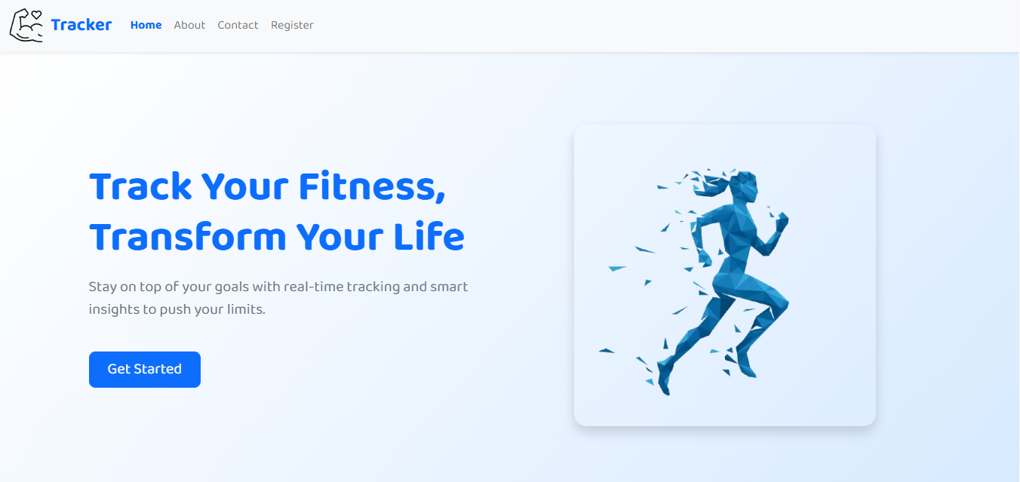

Login page
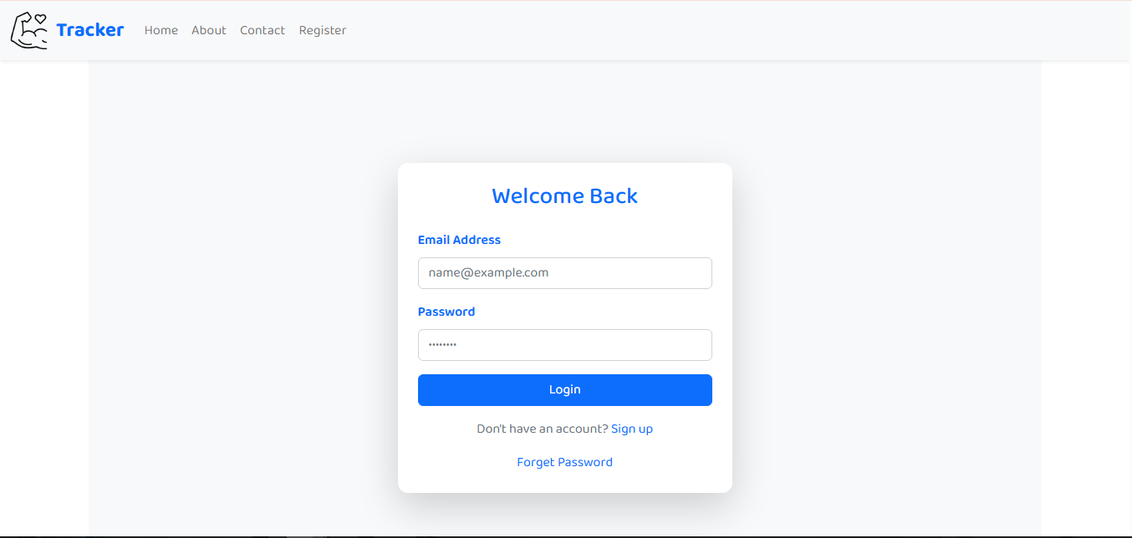

Signup Page
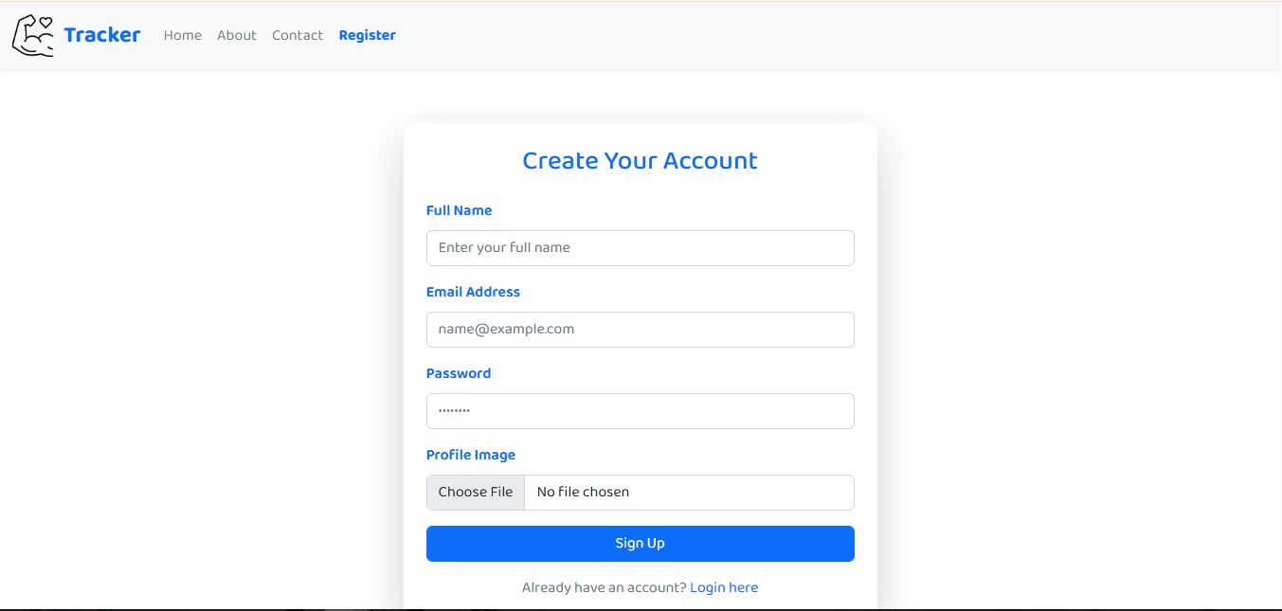

User Dashboard
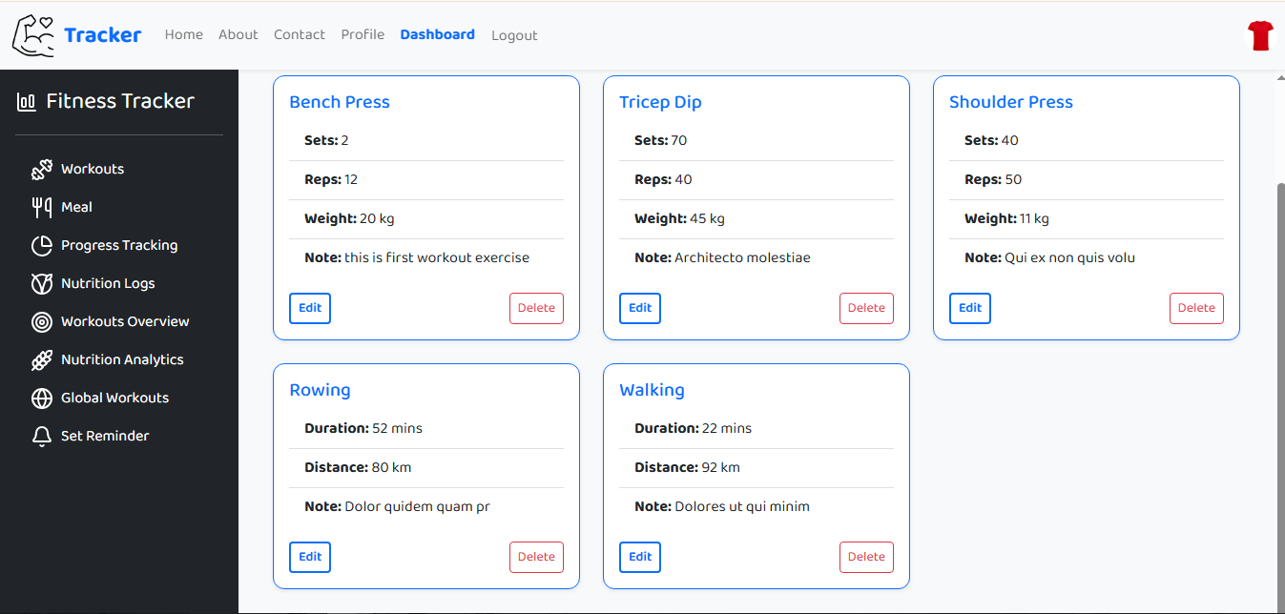
Profile
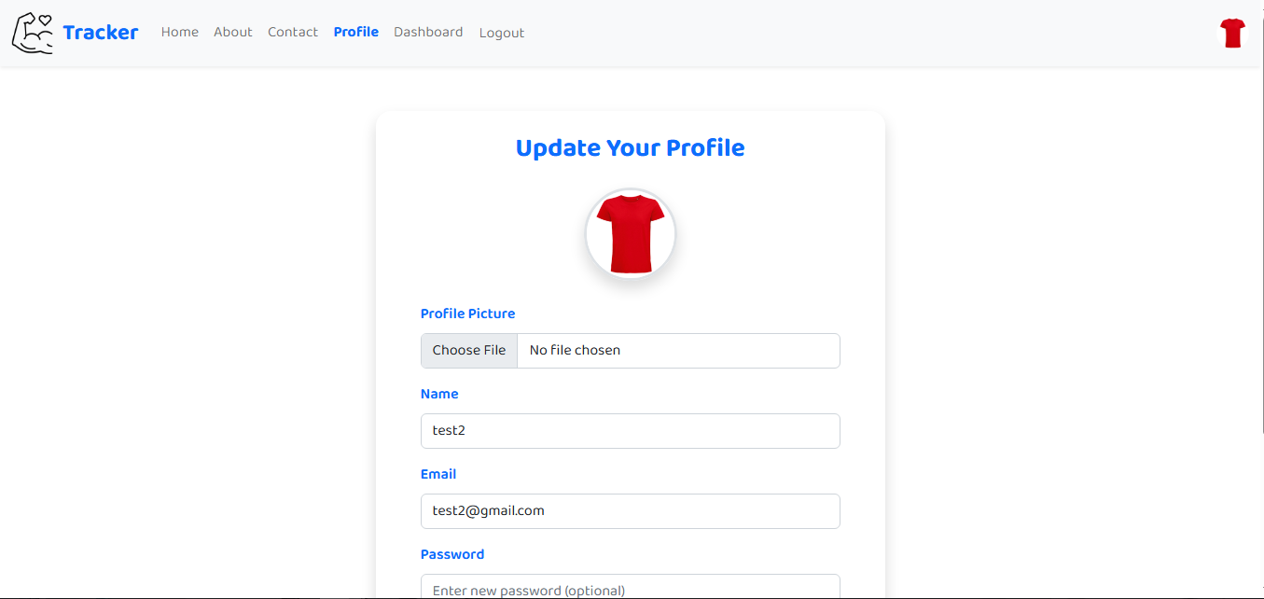

Workout Table
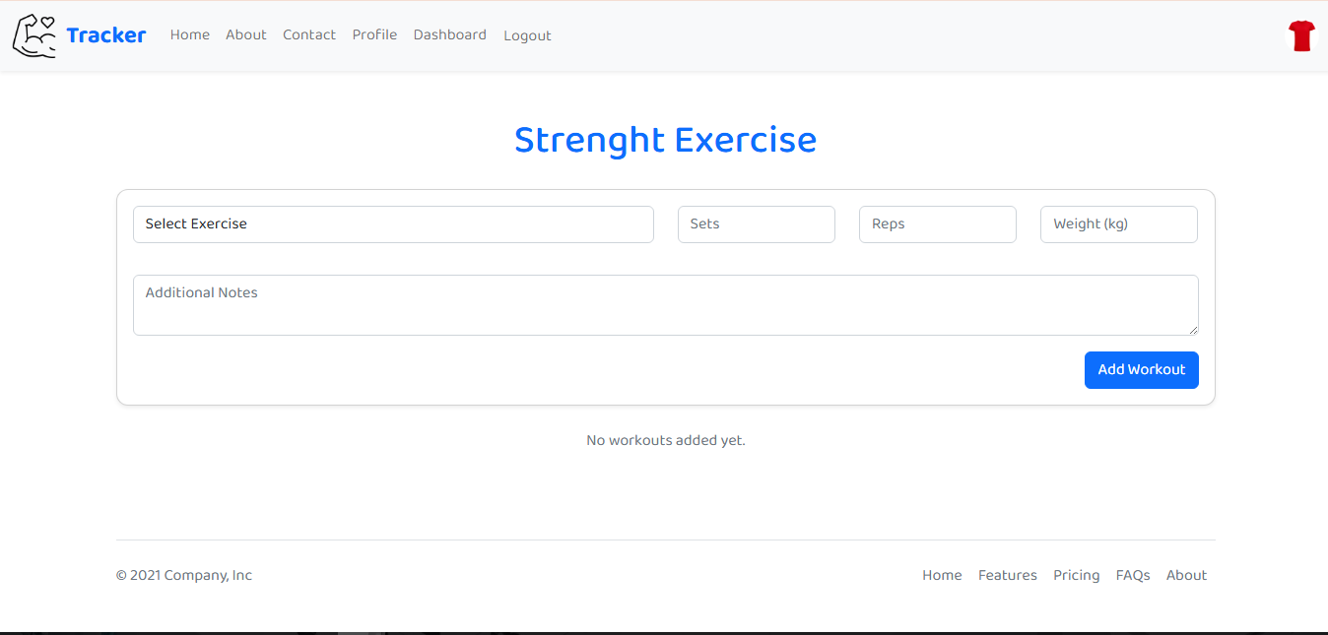

Thank You

